**Defect Id:** 001

**Defect Summary:** Inconsistent promotional banner display across the Men, Women, and Kids sections on the homepage.

**Detected On:** 16/01/2025

**Detected By:** Pranita Panse

**Module:** Homepage (Men, Women, Kids Sections)

**Environment:** Browser – Chrome; OS – Windows 11

**Steps to reproduce:**

1. Navigate to https://en.aboutyou.de/.   
2. Navigate to the Men section: Promotional banners are displayed.  
3. Navigate to Women section: Promotional banners are displayed.  
4. Navigate to the Kids section: No promotional banners; products are displayed directly.

**Expected Result:**

Promotional banners should be consistently displayed across Men, Women, and Kids sections.

**Actual Result:**

Promotional banners are missing in the Kids section, creating an inconsistent user experience.

**Severity:** Medium

**Priority:** Low to Medium

[Points to be considered:

Low: If promotions are not a critical part of the Kids section strategy or if this is a minor UX issue that doesn’t significantly impact business goals.

Medium: If the inconsistency in displaying promotional content is unintentional and affects marketing efforts or sales in the Kids section.]

**Type of Defect:** UI Inconsistency

**Defect Status:** Open

**Reproducibility:** Always

**Comments:** Confirm with the business team whether this behaviour is intentional or requires alignment.

**Screenshots:**

1. **Kids Section Homepage Screenshot without Promotion Banners**

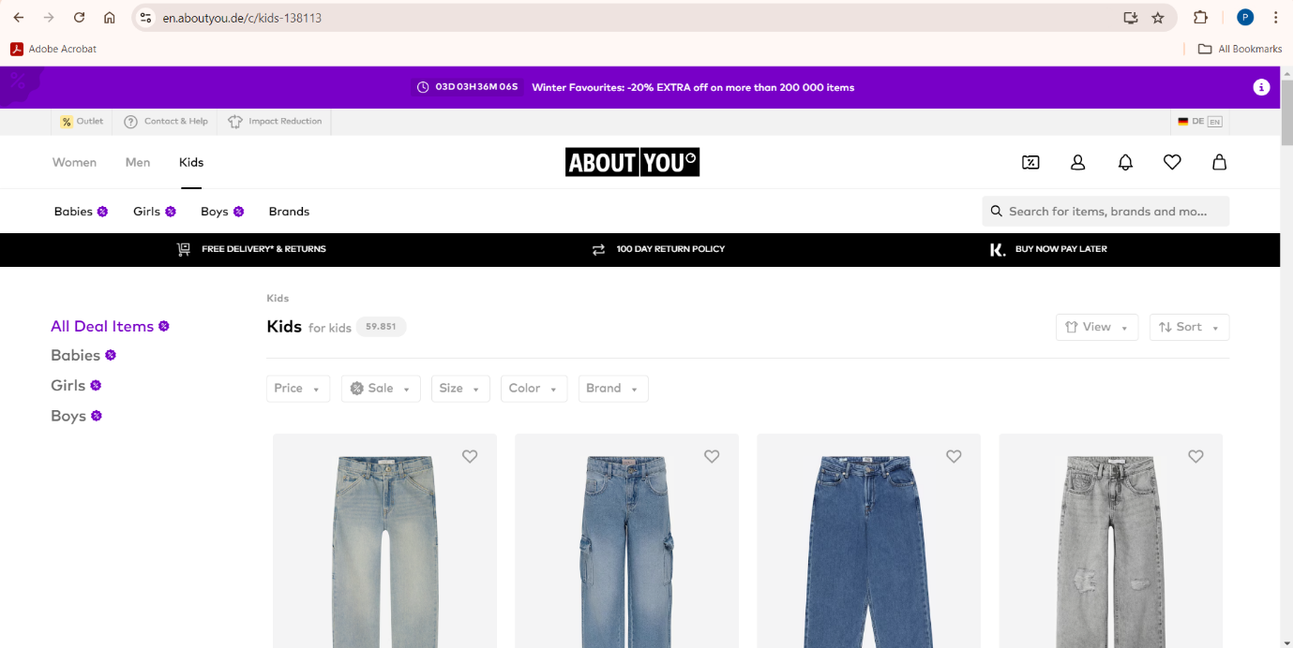

1. **Men Section Homepage Screenshot with Promotional Banners**

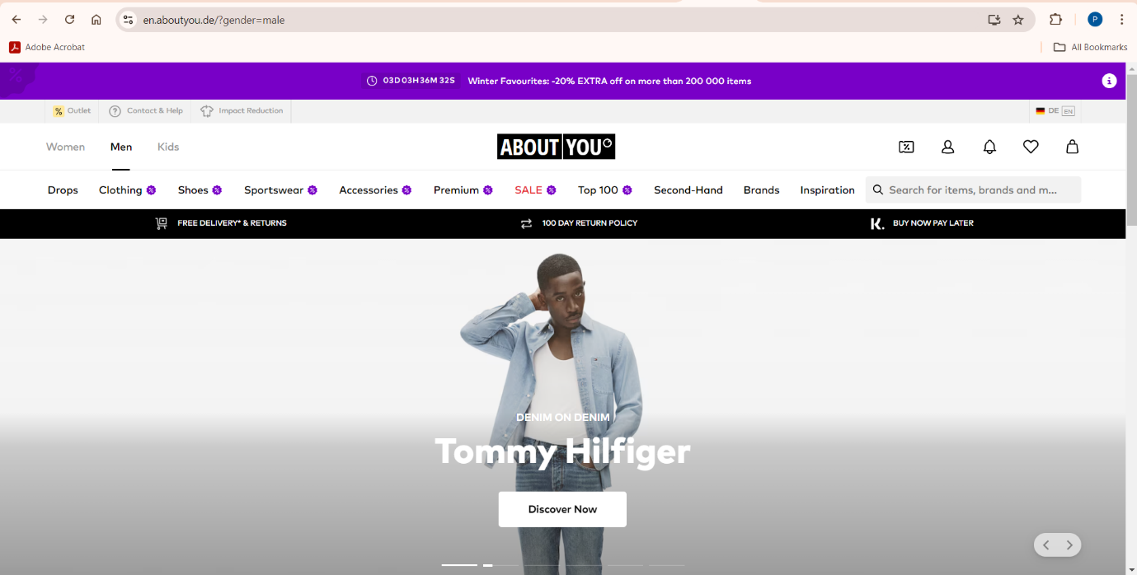

1. **Women Section Homepage Screenshot with Promotional Banners**

